

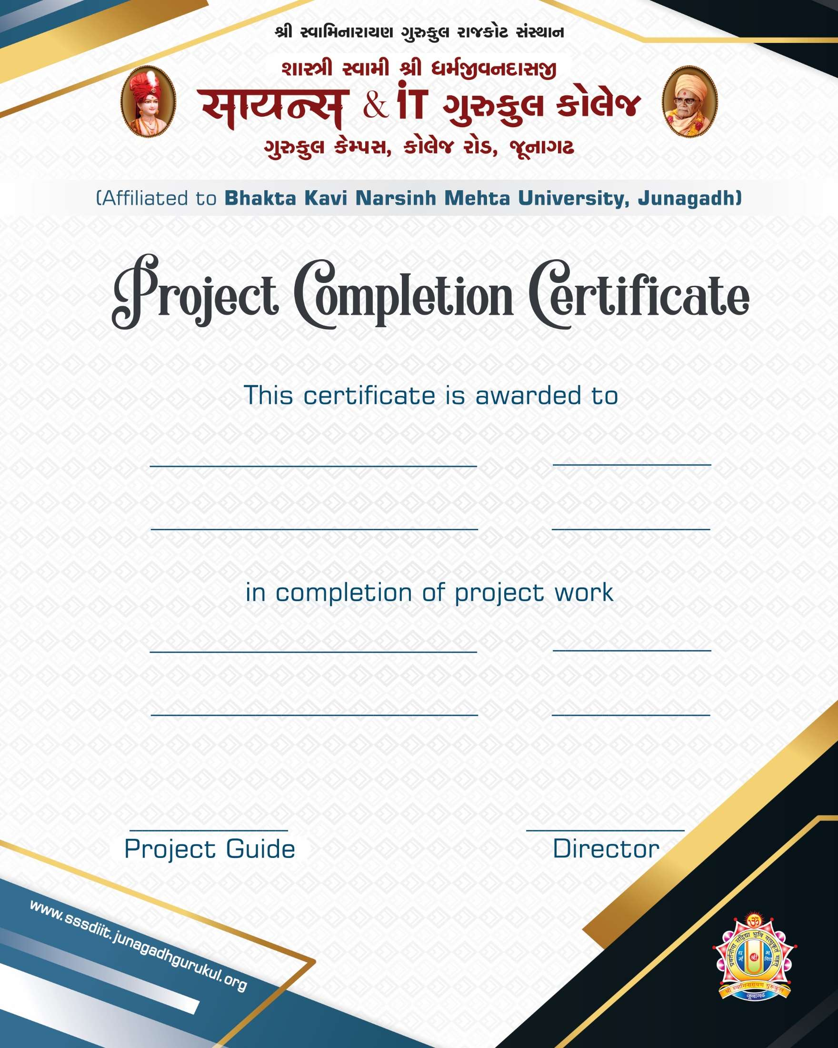

**Mr. Harsh D. Poshiya BCA5-2024**

**PHP 28/05/2024**

**MySQL 04/10/2024**

### Mr. Ripal Pandya Mr. Milind Anandpara

**A**

**PROJECT REPORT ON**

ONLINE-EXAMINATION-SYSTEM

**Submitted in Fulfillment of Requirements For Completion of Semester - 5 in Bachelor of computer application**

**Year 2024 To**

**SHASHTRI SWAMI SHREE DHARMAJIVANDASJI INSTITUTE OF INFORMATION TECHNOLOGY**

**JUNAGADH**

**Guided By: Prepared By:**

**Mr. Ripal Pandya Mr. Harsh D. Poshiya Mr. Milind Anandpara**

The *Online Examination System* project has been developed as part of the curriculum for the Bachelor of Computer Application (BCA) program, undertaken during the 5th semester at **SSSDIIT College**, affiliated with **BKNM University**. This project is designed to provide a comprehensive solution for managing online examinations efficiently and securely, utilizing **PHP** for server- side scripting and **MySQL** as the database system.

With the rapid advancement of technology, the need for digital solutions in the field of education has increased significantly. The transition from traditional paper-based examinations to online systems has become a necessity for educational institutions globally. This project addresses the growing demand for a flexible, user-friendly, and secure examination system.

The *Online Examination System* enables administrators to create exams, manage student data, and evaluate performance automatically. It provides students with a seamless experience by allowing them to appear for exams from remote locations. The system is designed with security in mind, ensuring that the integrity of the examination process is maintained through features like timed sessions and secure authentication.

I would like to express my gratitude to my mentors, peers, and the faculty at **SSSDIIT College**, whose guidance has been instrumental in the completion of this project. Special thanks are extended to the **BKNM University** for providing the platform to undertake this academic endeavor.

We are very thankful to all whose have helped in preparing this project. We are feeling a great happiness to present this website project. First of all we would like to thank **“BKNM University”** who give me an opportunity to give a chance to prepare a project.

Before we get in to thick of the things we would to add a few heartfelt words for the people who were part of this project numerous ways, people who give unending support right from the stage project ideas was conceived. In particular we would like to thank **Mr. Ripal Pandya , Mr. Milind Anandpara** , who has always inspired us and has directed us towards the successful completion of our project. They have been the guided through the project and their encouragement has left me indebted to them.

We are very thankful to the **Director Sadhu RushikeshdashjiSwami** and the **Asst. Director Mr. Rajesh Bharad** of **Shastri Swami Shree Dharmajivandasji Institute of Information Technology – Junagadh**.

We are also thankful to our classmate and few other people who helped us directly or indirectly in solving problem and in making our web development project more efficient and attractive.

Thank you…

**Date:** 04/10/2024 Mr. Harsh D. Poshiya

**Place:** JUNAGADH

|  |  |  |
| --- | --- | --- |
| **NO Particulars Page No** | | |
| **1** | Project Profile | 1 |
| **2** | Use of System Development Life Cycle Model | 2 |
| **3** | Feasibility Study | 5 |
| **4** | Requirement Gathering | 9 |
| **5** | **Requirement Analysis**   1. Hardware and Software Requirement 2. Front - End Tools 3. Back - End Tools 4. Other Tools & Technology Used | 11 |
| **6** | Project Abstracts (User Roles & Capabilities) | 14 |
| **7** | Proposed System | 16 |
| **8** | Advantages & Limitations of Proposed System | 18 |
| **9** | Evaluative Report Using Pert Chart and Gantt Chart | 20 |
| **10** | **Data Flow Diagram**   1. Context level 2. 1st Level 3. 2nd Level | 22 |
| **11** | Use Case Diagram | 25 |
| **12** | Flow Chart | 26 |
| **13** | Cost Estimation | 30 |
| **14** | Data Dictionary | 32 |
| **15** | Screen Layouts | 37 |
| **16** | Special Utilities | 50 |
| **17** | Testing | 51 |
| **18** | Implementation | 56 |
| **19** | Bibliography | 57 |

# PROJECT PROFILE

|  |  |
| --- | --- |
| **Project Title** | ONLINE-EXAMINATION-SYSTEM |
| **Project Description** | The **Online Examination System** is a web-based application designed to facilitate the creation, administration, and evaluation of exams in a secure and efficient manner. It allows administrators to manage question banks, set time limits, and track student performance, while students can attempt exams from any location with real-time grading for objective questions. |
| **Front End** | PHP |
| **Back End** | MYSQL |
| **Other Tools** | HTML,CSS,JAVASCRIPT |
| **Guide** | Mr. Ripal Pandya , Mr. Milind Anandpara |
| **Submitted To** | S.S.S.D.I.I.T College |

**USE OF SYSTEM DEVELOPMENT LIFE CYCLE MODEL**

Software Development Life Cycle (SDLC) is a process for development of software. There are some steps to follow to create a software application.

In an SDLC the steps follows requirement gathering. In requirement gathering questionnaire, personal interview etc. are the method for gathering information. Analysis phase includes creating Software Requirement Specification and analyze the gathered data. In design phase, design of Software application i.e. database design and GUI design have to be prepared. In coding phase, coding is done of different modules and forms. In testing phase, the different type of testing is done like integration testing, unit testing, system testing and at last the created software is implemented and maintained.

Following are the different Life Cycle Model example.

* Waterfall model
* Iterative waterfall model
* Prototyping model
* Evolutionary model
* Spiral model
* R.A.D. model (Rapid Application Development)

I am following waterfall model following is diagrammatic representation of different phase of waterfall model.

#### WATERFALL MODEL :-

* **Requirement Gathering and Analysis :-** All possible requirements of the system to be developed are captured in this phase and documented in a requirement in a requirement specific doc.
* **System Design :-** The requirement specification from first phase is studied this phase is studied in this phase and system design in prepared, system Design helps in defining overall system architecture.
* **Implementation :-** With inputs from system design the system is system is first developed in small programs called nits which are integrated in the next phase, each unit is developed and tested for its functionality which is referred to as unit testing.
* **Integration and Testing :-** All the units develop in the Implementation phase are integrated into a system after testing of each unit post integration the entire system is tested for any faults and failures.
* **Deployment of system :-** Once the functional and non-functional testing is done the product is developing the customer environment or released into the market.
* **Maintenance :-** All the units develop in the Implementation phase are integrated into a system after testing of each unit post integration the entire system is tested for any faults and failures.

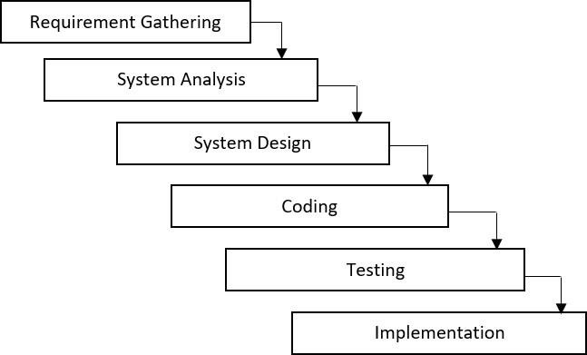

# FEASIBILITY STUDY

The development of the *Online Examination System* requires a thorough feasibility study to evaluate the technical, operational, economic, and legal aspects of the project. This study ensures that the system can be successfully implemented within the constraints of time, cost, and resources. Below is the detailed analysis of the feasibility for the project.

### Technical Feasibility :

The technical feasibility evaluates whether the current technology and infrastructure are sufficient to implement the *Online Examination System*.

* + Programming Language and Framework: The project will be developed using PHP, a widely-used server-side scripting language that offers high compatibility with web servers and ease of integration with MySQL.
  + Database Management: MySQL is used for managing data efficiently. It is a robust and scalable relational database management system that can handle large volumes of data, making it suitable for storing student information, exam details, and results.
  + Server and Hosting Requirements: A web server capable of running PHP scripts and supporting MySQL databases will be required. Hosting the system on a cloud-based platform can ensure reliability, scalability, and ease of access.
  + Security: With secure authentication mechanisms, data encryption, and secure data transmission (using HTTPS), the system can ensure the privacy and integrity of sensitive exam data.

**Conclusion:** The technical tools required for the project are readily available and manageable within the current infrastructure, making the project technically feasible.

### Operational Feasibility :

This aspect examines whether the system will operate effectively within the intended user environment.

* + User Requirements: The system will be used by three primary groups:
    - Administrators: To create and manage exams, user accounts, and results.
    - Instructors: To upload questions, set time limits, and monitor student progress.
    - Students: To log in, take exams, and view results.
  + Ease of Use: A user-friendly interface will be developed to ensure that students and administrators can easily navigate the system. The system will include clear instructions and responsive design to accommodate different devices (desktop, tablets, mobile phones).
  + Training and Support: Minimal training will be required for users since the system will have intuitive navigation. User manuals and support resources will be provided as necessary.

**Conclusion:** The system is operationally feasible and will enhance the examination experience by providing a flexible, user-friendly, and efficient solution.

### Economic Feasibility :

The economic feasibility focuses on the cost-benefit analysis of the project.

* + Development Costs: As an academic project, the cost of development is minimal. The tools (PHP and MySQL) are open-source and freely available. The primary expenses would be related to hosting and server maintenance, which can be optimized by selecting affordable hosting plans.
  + Implementation Costs: Once developed, the cost of deploying the system will involve web hosting and domain registration. These costs are expected to be relatively low and manageable within a small budget.
  + Economic feasibility assesses whether the cost of developing and implementing the **Online Examination System** is justifiable and within budget constraints. This analysis helps determine if the project will provide value over time, considering the costs involved and the potential benefits.

#### Estimated Cost of the Project: ₹500,000 (Approx.)

**Conclusion:** The project is economically feasible, with minimal development and deployment costs and long-term benefits that outweigh the initial investment.

### Legal Feasibility :

This assesses the legal implications of implementing the system.

* + Data Privacy and Security: The system will handle sensitive data, including student details and exam results. Adhering to data protection regulations (such as the GDPR or local regulations) is

crucial. The system will ensure secure data storage and transmission, and users' consent will be required before processing personal data.

* + Copyright Issues: Any third-party materials used in exam questions (e.g., images, articles) must comply with copyright laws, ensuring that permission is obtained or open-source content is used.

**Conclusion:** By adhering to legal regulations, the project is legally feasible and can be deployed without significant legal hurdles.

### Schedule Feasibility :

The project timeline is planned for completion within the academic semester, aligning with the goals of the 5th-semester curriculum.

* + Development Phases:
    - Phase 1: Requirements gathering and initial design (1-2 weeks).
    - Phase 2: Database design and back-end development using PHP and MySQL (3-4 weeks).
    - Phase 3: Front-end development, integrating the user interface (2-3 weeks).
    - Phase 4: Testing and debugging (1-2 weeks).
    - Phase 5: Final deployment and documentation (1 week).

**Conclusion:** The project can be completed within the allocated time frame, making it schedule-feasible.

# REQUIREMENT GATHERING

The *Online Examination System* project aims to streamline the process of conducting exams online. The requirement gathering phase is crucial for understanding the needs of stakeholders and ensuring the system meets its intended goals. This phase captures both functional and non-functional requirements, ensuring that all necessary features are accounted for.

### Functional Requirements :

Functional requirements describe the specific behaviors and functionalities the system must have.

#### User Roles and Access Control

* + - Administrator:
      * Manage student and instructor accounts.
      * Create, modify, and delete exams.
      * Manage exam settings (time limits, number of attempts, etc.).
    - Students:
      * Register for the system and log in using unique credentials.
      * View available exams and take exams within the given time frame.
      * Receive immediate feedback/results after completing exams (if applicable).

#### Exam Management

* + - Question Bank:
      * Instructors should be able to upload exam questions to a centralized question bank.
      * Questions can be categorized by subjects, topics, and difficulty levels.
    - Timed Exams:
      * Each exam should have a specified duration, with countdown timers visible to students.
      * Auto-submit functionality when the exam time is up.
    - Exam Types:
      * Support for various question types (True/False, Short Answer, etc.).

#### Authentication and Security

* + - Login System:
      * Secure login system for students, instructors, and administrators.
      * Password encryption and secure data transmission (HTTPS).
    - Two-Factor Authentication (Optional):
      * Implement two-factor authentication to enhance security.

### Stakeholder Requirements

Understanding stakeholder expectations is crucial to meeting project objectives.

#### Students

* + - **Easy Access**: Ability to register, log in, and take exams without technical difficulties.
    - **Feedback**: Immediate feedback on performance post-exam, where applicable.

#### Instructors

* + - **Efficient Exam Management**: Ability to easily create exams, upload questions, and monitor student progress.

# REQUIREMENT ANALYSIS

### Hardware and Software Requirements

#### Hardware Requirements

* + - Development Machine:
      * Processor: Intel Core i5 or higher / AMD equivalent.
      * RAM: Minimum 8 GB (16 GB recommended for smoother multitasking).
      * Storage: At least 256 GB SSD for faster performance.
      * Network: High-speed internet connection for code deployment and testing.

#### Software Requirements

* + - Operating System:
      * Development: Windows, macOS, or Linux.
    - Web Server:
      * Apache HTTP Server (Recommended) or Nginx.
    - Database:
      * MySQL (or MariaDB as an alternative).
    - Programming Language:
      * PHP (Version 7.4 or higher).
    - Text Editor/IDE:
      * Visual Studio Code, Sublime Text, or PHPStorm.
    - Browser Compatibility:
      * Chrome, Firefox, Safari, and Microsoft Edge.

### Front-End Tools (PHP)

Though PHP is primarily a back-end tool, it often interacts with front-end components by dynamically generating HTML, CSS, and JavaScript content on the server. In this context:

* **PHP**:
  + **Purpose**: Server-side scripting language that dynamically generates web pages for the user interface.
  + **Use in Front-End**: PHP is responsible for embedding dynamic content within the front-end of the system (e.g., user-specific data, exam questions, results). PHP helps in creating HTML pages dynamically by fetching data from the MySQL database.

### Back-End Tools (MySQL)

MySQL will serve as the back-end database management system for your project.

#### MySQL:

* + **Purpose**: MySQL is a relational database management system used to store, retrieve, and manage data.
  + **Use**:
    - **User Data**: Stores information about students, instructors, and administrators.
    - **Exam Management**: Stores exam-related data (questions, options, correct answers, exam schedules).
    - **Result Data**: Stores and processes the results of exams.
    - **Relationships**: Handles relational data across tables (e.g., linking students to their exams and results).
  + **Features**: MySQL provides CRUD operations (Create, Read, Update, Delete), relational data management, indexing for performance optimization, and data security.

### Other Tools & Technology Used

#### HTML (HyperText Markup Language)

* + - **Purpose**: The standard language for creating the structure of web pages.
    - **Use**: HTML will define the structure of all web pages in the Online Examination System, including login pages, exam interfaces, and result pages. PHP will dynamically generate HTML content based on the database.

#### CSS (Cascading Style Sheets)

* + - **Purpose**: Defines the look and feel of the web pages.
    - **Use**: CSS will be used to style the HTML content, ensuring that the user interface is visually appealing and responsive. It will be responsible for layout, colors, fonts, and overall aesthetics.

#### Bootstrap

* + - **Purpose**: A responsive front-end framework that helps design modern, responsive web pages.
    - **Use**: Bootstrap will be used to create a mobile-friendly design for the system, ensuring that the interface works well across different screen sizes (desktops, tablets, and mobile phones). Pre-built components like forms, buttons, modals, and navigation bars can be utilized for faster front-end development.

#### JavaScript

* + - **Purpose**: A scripting language that adds interactivity and dynamic behavior to web pages.
    - **Use**: JavaScript will be used for real-time client-side validation, handling user actions (e.g., answering questions, clicking buttons), and providing a smoother user experience (e.g., countdown timers for exams, dynamically loading content without reloading the page).

# PROJECT ABSTRACTS

The *Online Examination System* is a web-based application designed to facilitate the management and conduct of exams in an online environment. It eliminates the need for traditional paper-based exams, making the process more efficient, scalable, and accessible. The system is primarily targeted at educational institutions but can also be used by organizations for recruitment and certification purposes.

The platform offers functionalities for three key user roles: Administrators, Instructors, and Students. Administrators can manage users and oversee exam settings, instructors can create and assign exams, while students can attempt exams from anywhere and view their results in real time. The system ensures the security and integrity of the examination process, incorporating features like timed exams, automated grading for objective questions, and result analysis.

Through automation, the platform significantly reduces administrative overhead, provides instant feedback, and supports multiple exam types, including multiple-choice questions, true/false, short answers, and more. This system aims to streamline the examination process while maintaining fairness**,** accuracy, and convenience.

### Key Features:

#### User Management:

* + Admins can create, update, and delete users.
  + Different roles are assigned (Admin, Student).

#### Exam Management:

* + Admin can create exams, set time limits, and assign them to specific students or groups.
  + Questions can be added manually or selected from a question bank.

#### Question Bank:

* + Admin can manage a reusable collection of exam questions.
  + Supports various question types like MCQs, True/False.

#### Automated Grading:

* + System automatically grades objective-type questions.
  + Instructors can manually grade subjective answers and provide feedback.

#### Student Portal:

* + Students can log in to access available exams, complete them, and view their results.
  + Results are shown instantly for auto-graded questions, and detailed feedback is provided by instructors.

# PROPOSED SYSTEM

The proposed *Online Examination System* is a web-based application designed to digitize and automate the process of conducting exams for educational institutions. It eliminates the limitations of traditional paper- based exams by providing an efficient, secure, and scalable solution for both instructors and students. The system ensures seamless exam management, from user registration to result generation, while maintaining data integrity and security.

### Objectives of the Proposed System:

#### Efficiency and Automation:

Automate the entire exam lifecycle, from creating and scheduling exams to grading and publishing results, thereby reducing administrative overhead and human error.

#### Accessibility:

Provide students with the ability to take exams from anywhere, at any time, using any internet-enabled device, ensuring convenience and flexibility.

#### Security:

Ensure that the examination process is secure by implementing features like user authentication, timed exams, and data encryption to prevent unauthorized access and cheating.

#### Scalability:

The system can handle multiple users simultaneously, making it suitable for institutions with a large number of students.

#### Instant Feedback and Result:

Provide students with immediate feedback for objective-type questions and detailed performance analysis post-exam, allowing for faster result generation and review.

### Key Features of the Proposed System:

#### User Registration and Authentication:

* + A secure login system for students and administrators.
  + Role-based access control ensures that each user has access to only the features they are authorized to use.

#### Exam Creation and Management:

* + Admin can create exams with various question formats (multiple-choice, true/false).
  + Exams can be scheduled and assigned to specific student groups or classes.
  + Time limits and randomization of questions can be set to ensure fairness.

#### Question Bank:

* + A centralized repository where instructors can add, edit, and manage questions.
  + Supports categorization and tagging of questions for easy retrieval and reuse in future exams.

#### Taking Exams:

* + Students can log in to view their assigned exams, start exams, and submit their answers.
  + Exams are timed, with automatic submission when the time limit expires.
  + Objective questions are graded automatically, and the results are displayed immediately.

# ADVANTAGES & LIMITATIONS OF PROPOSED SYSTEM

### Advantages :

#### Convenience:

* + Students can take exams from any location, reducing logistical challenges.
  + Instructors can manage exams efficiently without manual grading or paper handling.

#### Cost-Effective:

* + The system reduces the costs associated with printing and distributing exam papers.
  + Automating grading for objective questions saves time and resources.

#### Environmental Impact:

* + The online system reduces paper usage, contributing to environmental sustainability.

#### Scalable and Flexible:

* + The system can be expanded to support more users as the institution grows, and it can handle various types of exams (formative assessments, mock exams, etc.).

### Limitations :

#### Internet Dependency

* + **Limitation:** The system is fully dependent on a stable internet connection for both examiners and students. Any interruption in internet connectivity during the exam could lead to difficulties in submitting answers or completing the exam.
  + **Impact:** Students in areas with unreliable or slow internet connections may face challenges in completing their exams on time.

#### Accessibility for Technologically Disadvantaged Users

* + **Limitation:** The system assumes that all users (students and instructors) have access to devices such as laptops, smartphones, or tablets with sufficient technical knowledge to navigate the platform.
  + **Impact:** Technologically disadvantaged users may struggle with using the system or face difficulties in completing exams, especially if they are not familiar with online tools.

#### Browser Limitations

* + **Limitation:** The system is dependent on browser compatibility and performance. Users may experience different behavior or display issues based on the browser they are using (e.g., Internet Explorer, outdated versions of Chrome/Firefox).
  + **Impact:** Some features may not work as intended across all browsers, leading to inconsistencies in the user experience.

**Pert Chart:**

# PERT CHART AND GANTT CHART

PERT (Project Evaluation and Review Technique) charts consist of a network of boxes and arrows. The boxes represent activities and the arrows represent task dependencies. PERT charts are a more sophisticated form of activity chart. Where instead of making a single estimate for each task, pessimistic, likely and optimistic estimates are made. The boxes of PERT charts are usually annotated with the pessimistic, likely, and optimistic estimates for every task. There are thus not one but many critical paths, depending on the permutations of the estimates for each task. This makes analysis of critical path show by using shaded boxes. The PERT chart representation of the MIS problem of show follows.

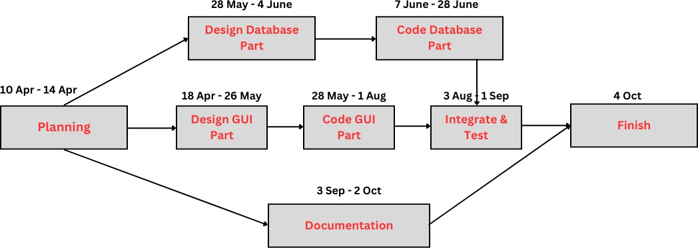

## Gantt Chart:

Gantt charts are mainly use of scheduling, budgeting, and resource planning. It allocates resource to activity include Staff, Hardware, Software, etc…

A Gantt chart is a special type of bar chart where each bar represents an activity. The bars are drawn along a time line. The length of each bar is proportional to the duration of time planned for the corresponding activity.

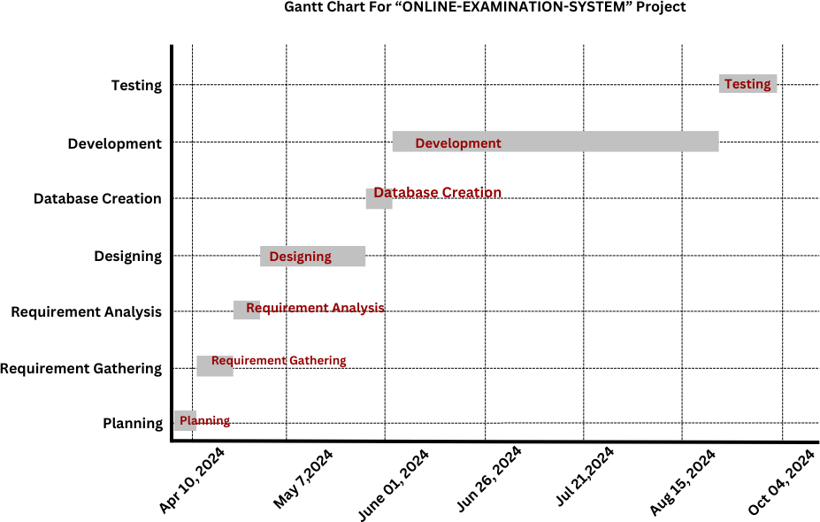

# DATA FLOW DIAGRAM

* In the discussion of “Detailed Life Cycle of Project” we have to concentrate on DFD (Data Flow Diagram). Here we have work on it while developing this software project.
* DFD (Data Flow Diagram):
* DFD is a graphical view of all system processes and transactions. With the DFD an End-User also can easily understand the system in a short time period. Also it is useful to find out problems or any complications with the system we are going to develop. We can easily get that whether we have understood the system as per the requirements of the customer or not by showing them this diagram. Thus DFD is a necessary phase while developing software.

1. **0 Level Diagram:**

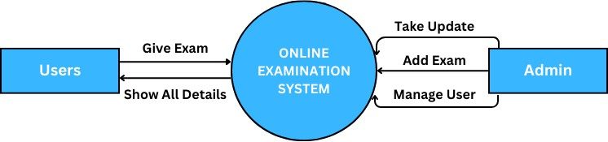

1. **1st Level Diagram:**

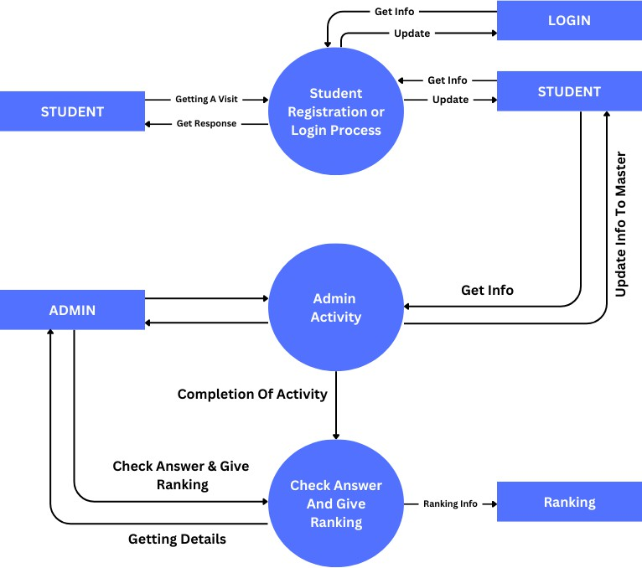

1. **2nd Level Diagram:**

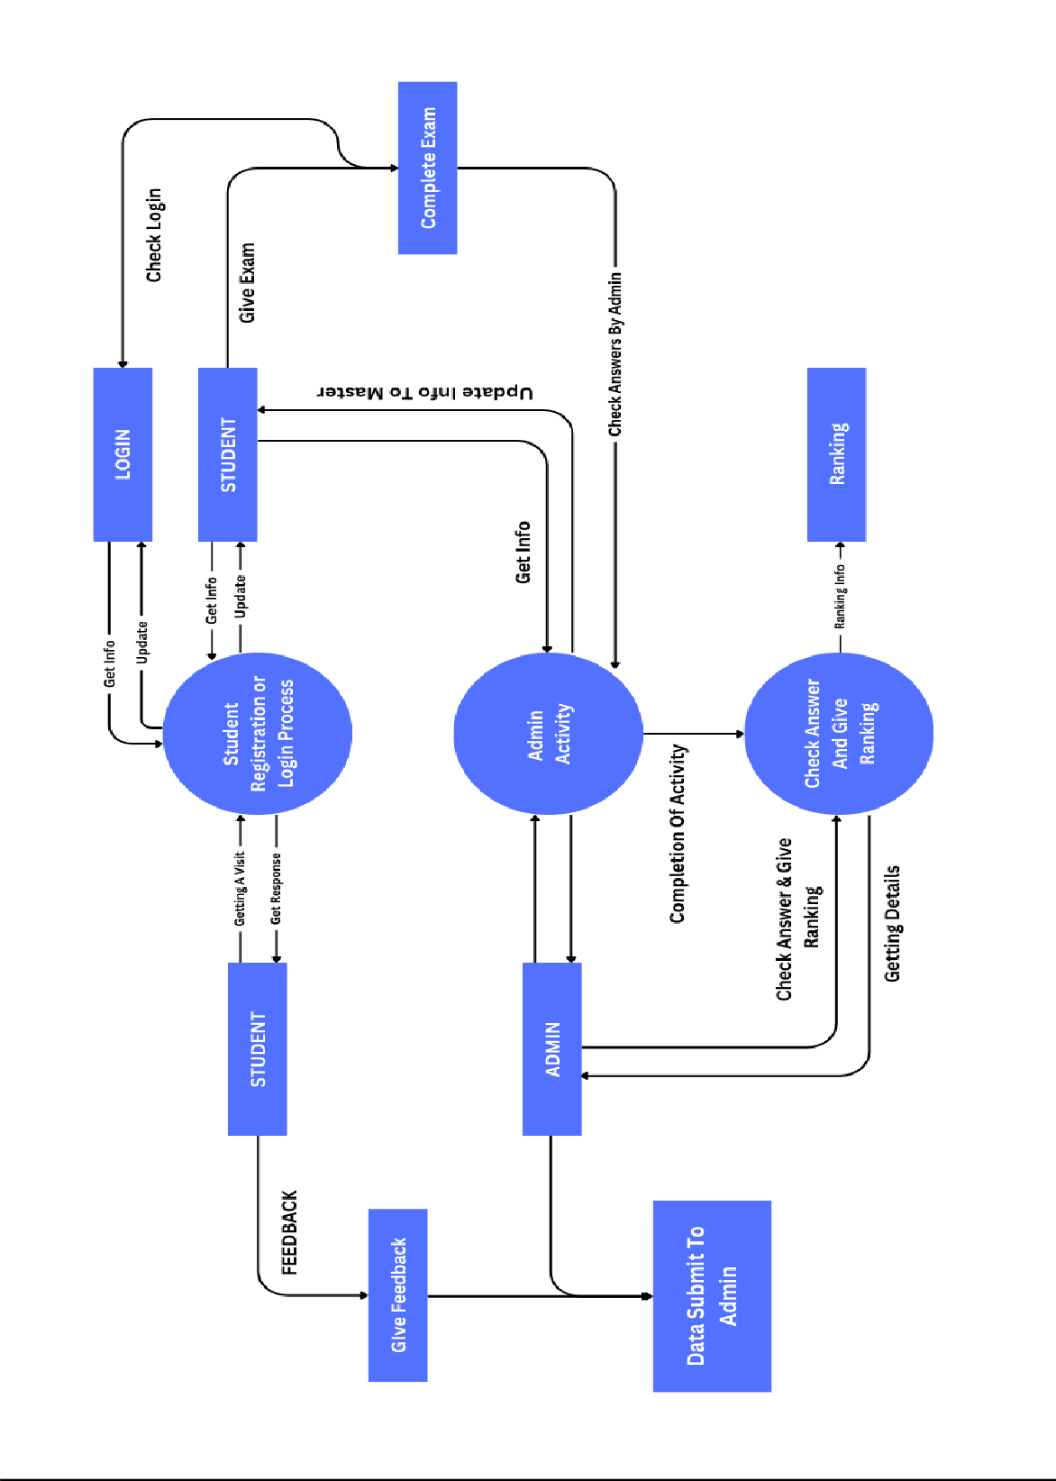

# USE CASE DIAGRAM

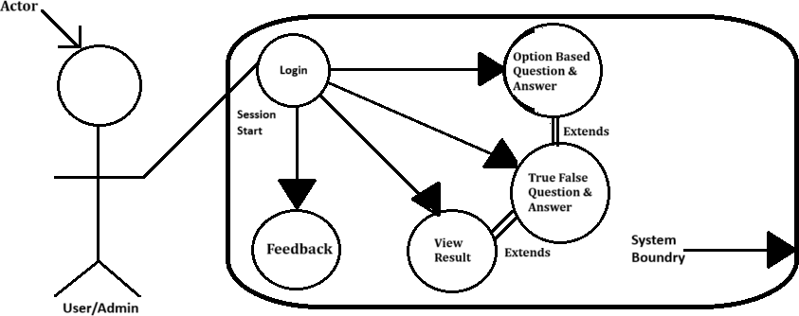

This diagram is a Use Case Diagram for an *Online Examination System*, illustrating the interaction between the User/Admin (actor) and the system. Here's a brief explanation:

#### User/Admin (actor) interacts with the system by:

* + - Login: The user starts by logging into the system.
    - Option-Based Questions & Answers and True/False Questions & Answers: The user answers these question types, which extend from the login session.
    - View Result: After completing the exam, the user can view the exam results.
    - Feedback: The user provides feedback after reviewing the results.

# FLOW CHART

A Flow is a pictorial representation of an algorithm. Programmers often use it as a program-planning tool for visually organizing a sequence of steps necessary to solve a problem using computer. It uses boxes of different shapes to denote different type of instructions. The actual instructions are written within these boxes using clear and concise statements. Solid lines having arrow marks connect these boxes to indicate the flow of operation, that is, the exact sequence in which to execute the instructions. The process of drawing a flowchart for an algorithm is known as flowcharting.

## Basic Flowchart Symbols:

#### Terminal Input/Output

**Processing Decision**

**Flow Lines Connectors**



**1)**

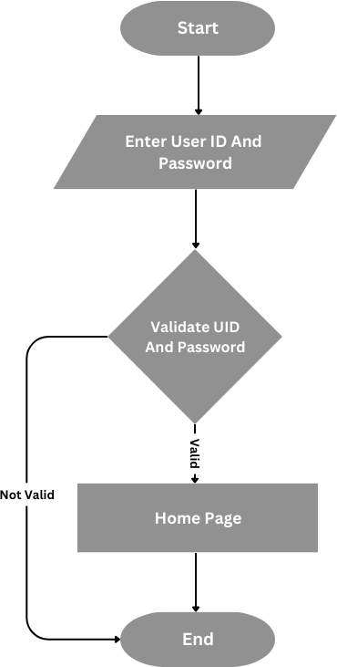

**2)**

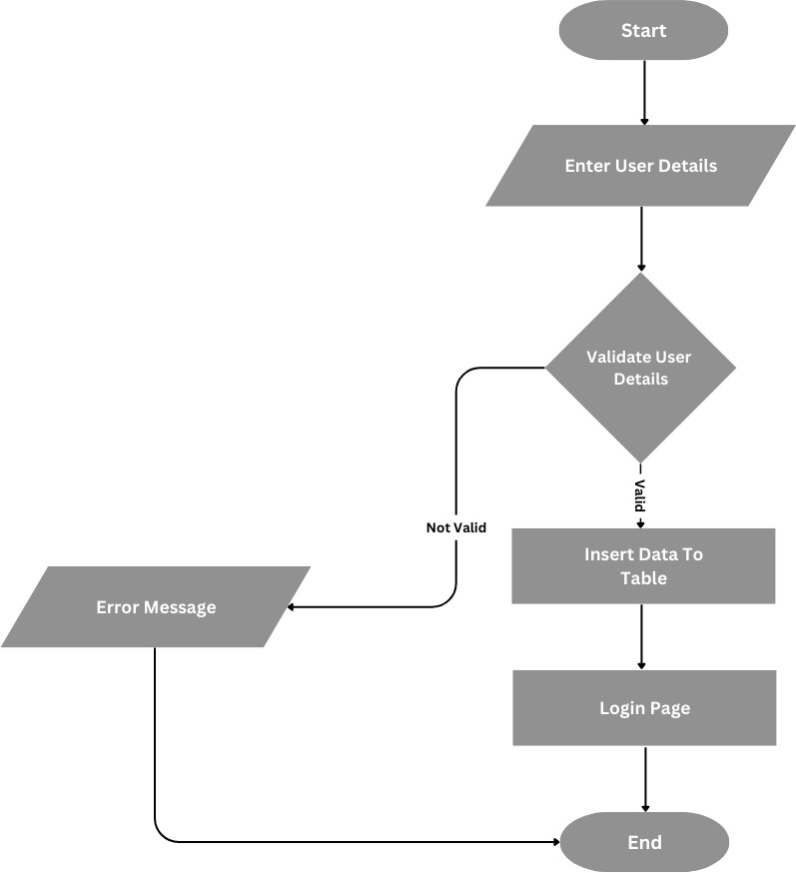

**3)**

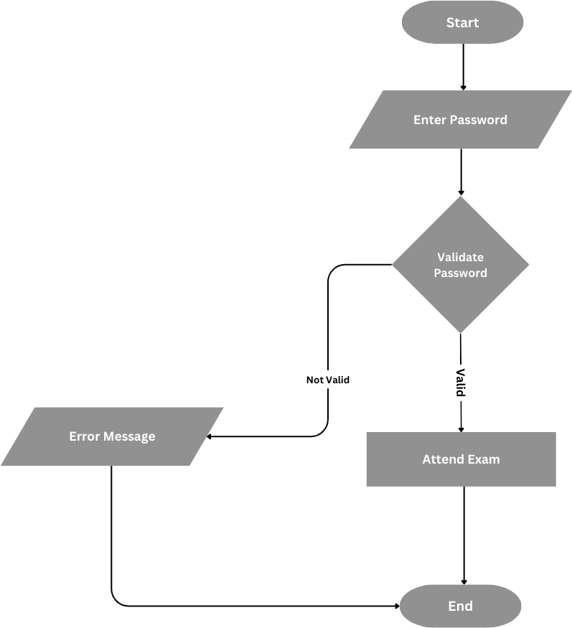

**COST ESTIMATION**

Cost estimation for an "Online Examination System" project can depend on various factors such as development time, hosting services, software tools, and resources.

### Development Costs

* + **Frontend & Backend Development:**
    - If you're hiring developers or contributing your own time, a freelancer may charge anywhere between ₹300 - ₹1,500 per hour depending on experience.
    - Total development time for a simple system could range from 100 to 300 hours, so:
      * Low estimate: ₹30,000 (₹300/hr * 100 hours)
      * High estimate: ₹4,50,000 (₹1,500/hr * 300 hours)
  + Your time (if self-developed): This may not have a direct cost but is important to factor in terms of effort and value.

### Software and Tools

* + **IDE (Integrated Development Environment):** Free (VS Code, Sublime Text, etc.) to paid options (₹2,000 - ₹5,000)
  + **Version Control System (e.g., GitHub):** Free for basic use, up to

₹500 per month for advanced collaboration tool

### Testing and QA

* + **Manual Testing:** Freelancers or testers might charge ₹500 - ₹1,000 per hour, or use testing tools (some free options available).
  + **Total testing cost:** ₹10,000 - ₹50,000 depending on project complexity.

### Maintenance and Updates

* + If you plan to maintain the system post-launch, annual maintenance could cost ₹10,000 - ₹50,000 depending on updates and bug fixes.

### Overall Estimated Cost

* + **Basic Version:** ₹40,000 - ₹1,00,000

#### Advanced Version (with scaling and cloud services): ₹1,00,000 -

₹5,00,000

**Cost Estimation Table for "Online Examination System" Project**

|  |  |  |  |
| --- | --- | --- | --- |
| **No.** | **Cost Item** | **Estimated Cost (₹)** | **Details** |
| **1** | Development Costs | ₹30,000 -  ₹4,50,000 | Includes frontend and backend development efforts |
| **2** | Software and Tools | ₹3,000 -  ₹10,500/year | For advanced collaboration tools (optional) |
| **3** | Testing and QA | ₹10,000 -  ₹50,000 | Freelance testers or testing tools |
| **4** | Maintenance and Updates | ₹10,000 -  ₹50,000/year | For ongoing updates and bug fixes |
| **5** | Overall Estimated Cost | ₹40,000 -  ₹5,00,000 | Based on scope, scaling, and features |

# DATA DICTIONARY & NORMALIZATION

**Database Name:** examination_system

**Table 1**: User

|  |  |  |  |
| --- | --- | --- | --- |
| **Column Name** | **Datatype(Size)** | **Constraints** | **Remarks** |
| **Name** | Varchar(255) |  |  |
| **Gender** | Varchar(255) |  |  |
| **College** | Varchar(255) |  |  |
| **Email** | Varchar(255) |  |  |
| **Mob** | Bigint(20) |  |  |
| **Password** | Varchar(255) |  |  |

**Table 2**: Questions

|  |  |  |  |
| --- | --- | --- | --- |
| **Column Name** | **Datatype(Size)** | **Constraints** | **Remarks** |
| **eid** | Text | primary Key |  |
| **qid** | Text |  |  |
| **qns** | Text |  |  |
| **choice** | Int(10) |  |  |
| **sn** | Int(11) |  |  |

**Table 3**: Answer

|  |  |  |  |
| --- | --- | --- | --- |
| **Column Name** | **Datatype(Size)** | **Constraints** | **Remarks** |
| **qid** | Text | FOREIGN KEY |  |
| **ansid** | Text |  |  |

**Table 4**: Quiz

|  |  |  |  |
| --- | --- | --- | --- |
| **Column Name** | **Datatype(Size)** | **Constraints** | **Remarks** |
| **eid** | text | FOREIGN KEY |  |
| **title** | Varchar(255) |  |  |
| **sahi** | Int(11) |  |  |
| **wrong** | Int(11) |  |  |
| **total** | Bigint(20) |  |  |
| **time** | Int(11) |  |  |
| **Intro** | Text |  |  |
| **Tag** | Varchar(255) |  |  |
| **date** | timestamp | Current_timestamp() |  |

**Table 5**: Option

|  |  |  |  |
| --- | --- | --- | --- |
| **Column Name** | **Datatype(Size)** | **Constraints** | **Remarks** |
| **qid** | Varchar(255) | FOREIGN KEY |  |
| **option** | Varchar(5000) |  |  |
| **optionid** | Text |  |  |

**Table 6**: Quiz

|  |  |  |  |
| --- | --- | --- | --- |
| **Column Name** | **Datatype(Size)** | **Constraints** | **Remarks** |
| **Email** | Varchar(255) |  |  |
| **Score** | Int(11) |  |  |
| **time** | timestamp | Current_timestamp() |  |

**Table 7**: Admin

|  |  |  |  |
| --- | --- | --- | --- |
| **Column Name** | **Datatype(Size)** | **Constraints** | **Remarks** |
| **Admin_id** | Int(11) | Primary key, A.I |  |
| **Email** | Varchar(255) |  |  |
| **Password** | Varchar(255) |  |  |

**Table 8**: History

|  |  |  |  |
| --- | --- | --- | --- |
| **Column Name** | **Datatype(Size)** | **Constraints** | **Remarks** |
| **Email** | Varchar(255) |  |  |
| **Eid** | text | FOREIGN KEY |  |
| **Score** | Int(11) |  |  |
| **Level** | Int(11) |  |  |
| **Sahi** | Int(11) |  |  |
| **Wrong** | Int(11) |  |  |
| **Date** | timestamp | Current_timestamp() |  |

**Table 9**: Feedback

|  |  |  |  |
| --- | --- | --- | --- |
| **Column Name** | **Datatype(Size)** | **Constraints** | **Remarks** |
| **Id** | Int(11) | Primary key |  |
| **Name** | Varchar(255) |  |  |
| **Email** | Varchar(255) |  |  |
| **Subject** | Varchar(255) |  |  |
| **Feedback** | Varchar(1000) |  |  |
| **Date** | Date |  |  |
| **Time** | Varchar(255) |  |  |

* **Client Side :**

# SCREEN LAYOUTS

## Index.php

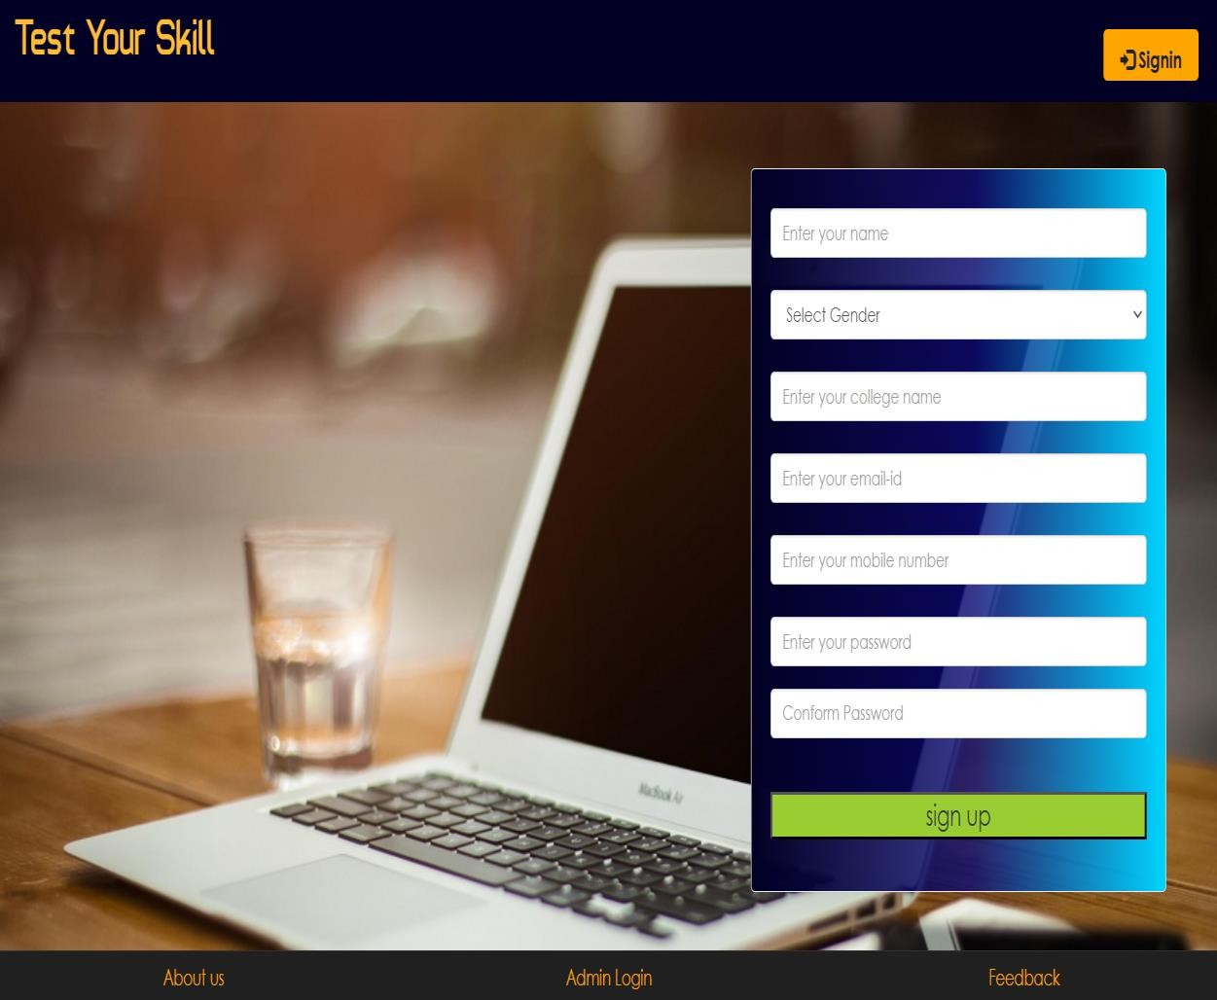

1. **Index.php(Login)**

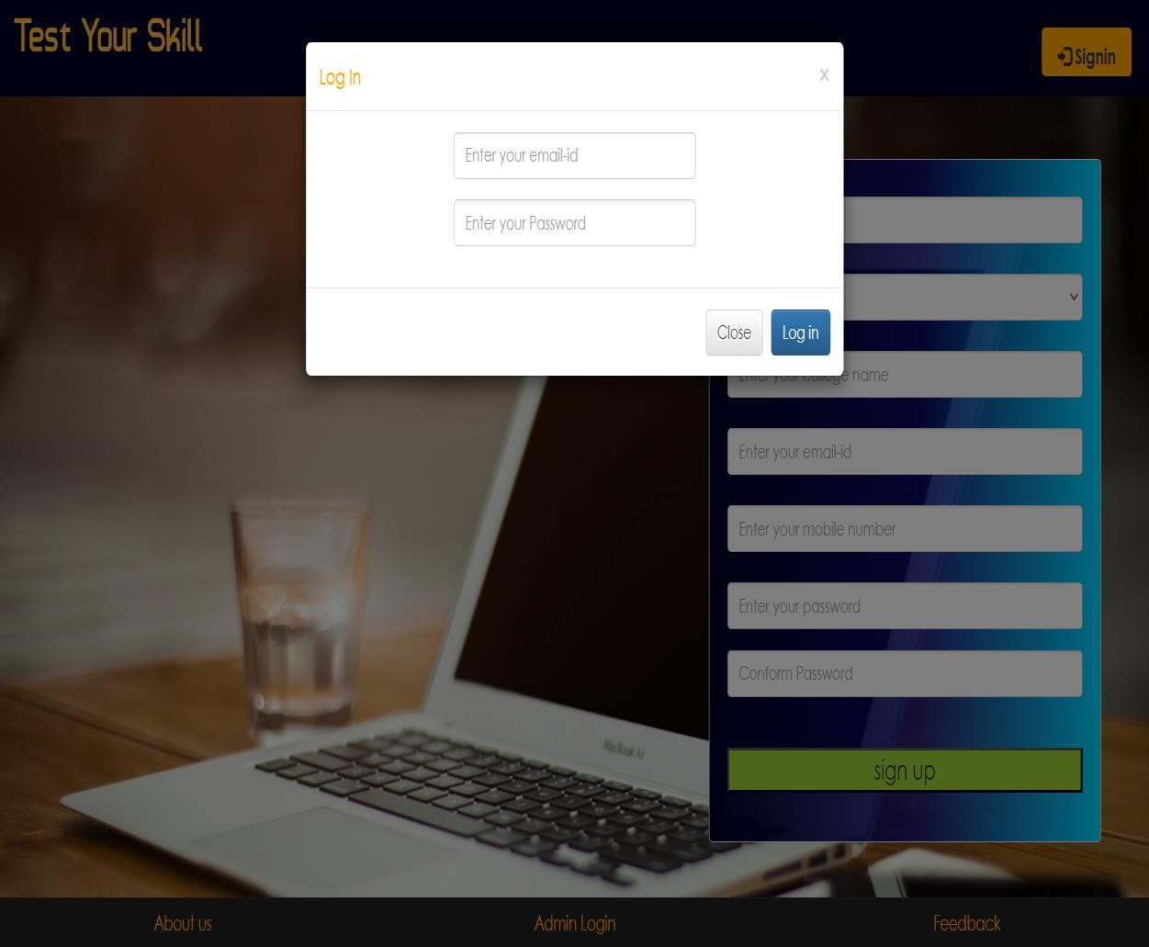

if ($count == 1)

{

while ($row = mysqli_fetch_array($result))

{

$name = $row['name'];

}

$_SESSION["name"] = $name;

$_SESSION["email"] = $email; header("location:account.php?q=1");

}

else

header("location:$ref?w=Wrong Username or Password");

## account.php?q=1

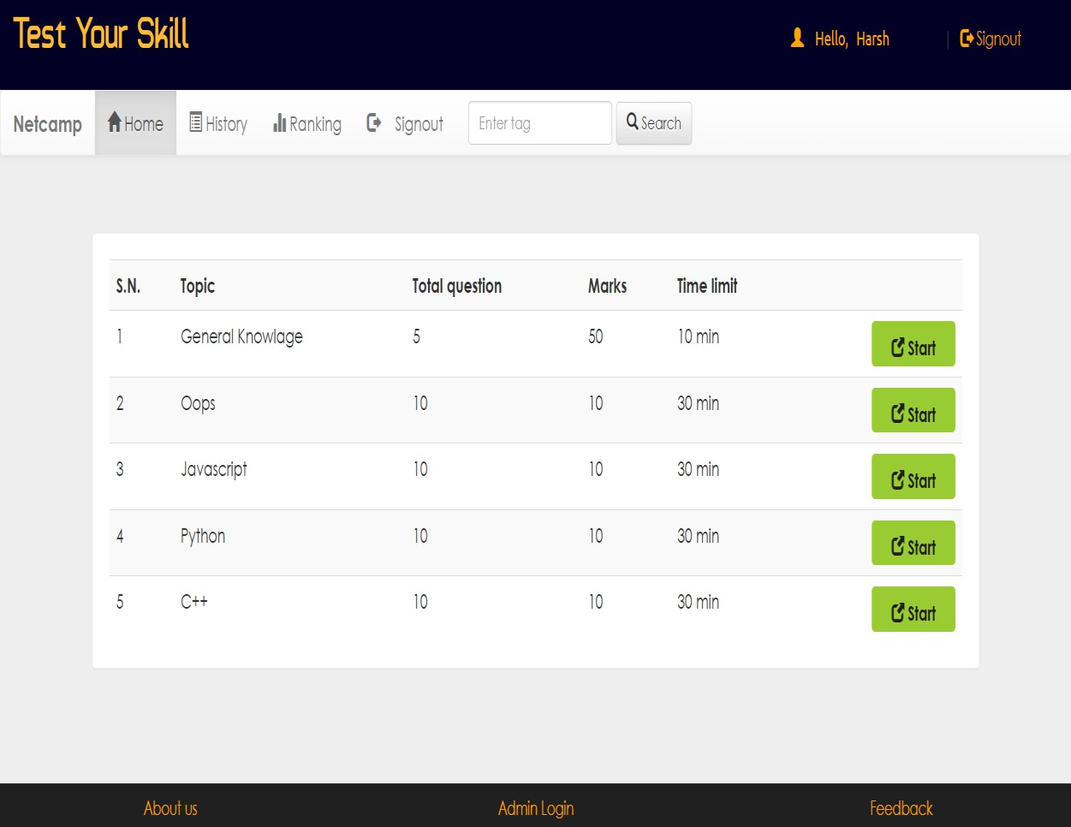

<li <?php if (@$_GET['q'] == 1) echo 'class="active"'; ?>>

<a href="account.php?q=1">

<span class="glyphicon glyphicon-home" aria-hidden="true"></span> &nbsp; **Home**

<span class="sr-only">(current)</span>

</a>

</li>

## account.php?q=2

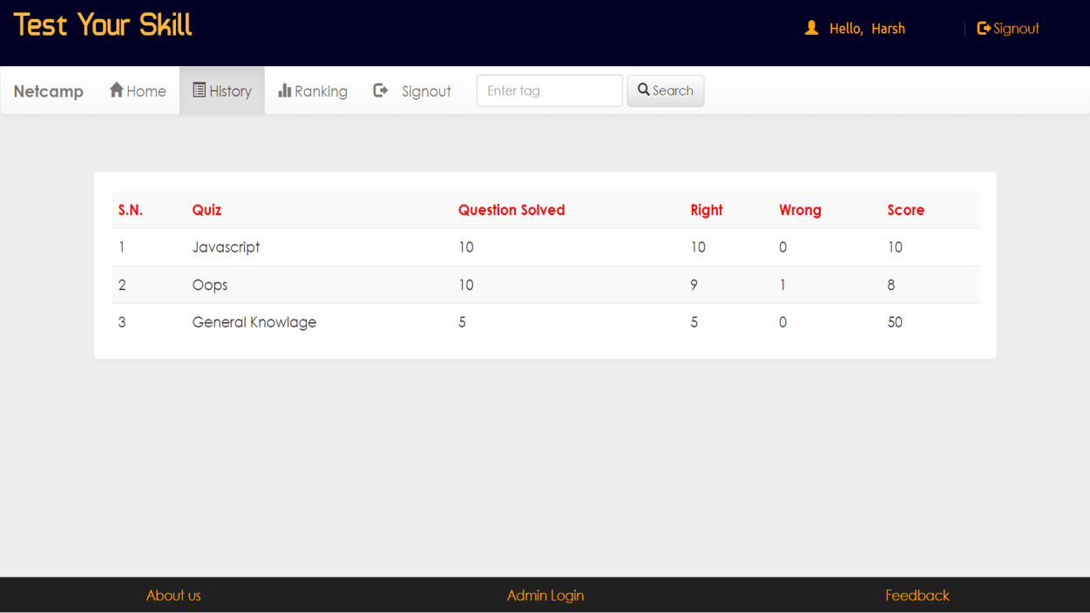

if (@$_GET['q'] == 2)

{

$q = mysqli_query($con, "SELECT * FROM history WHERE email='$email' ORDER BY date DESC ") or die('Error197');

}

## account.php?q=3

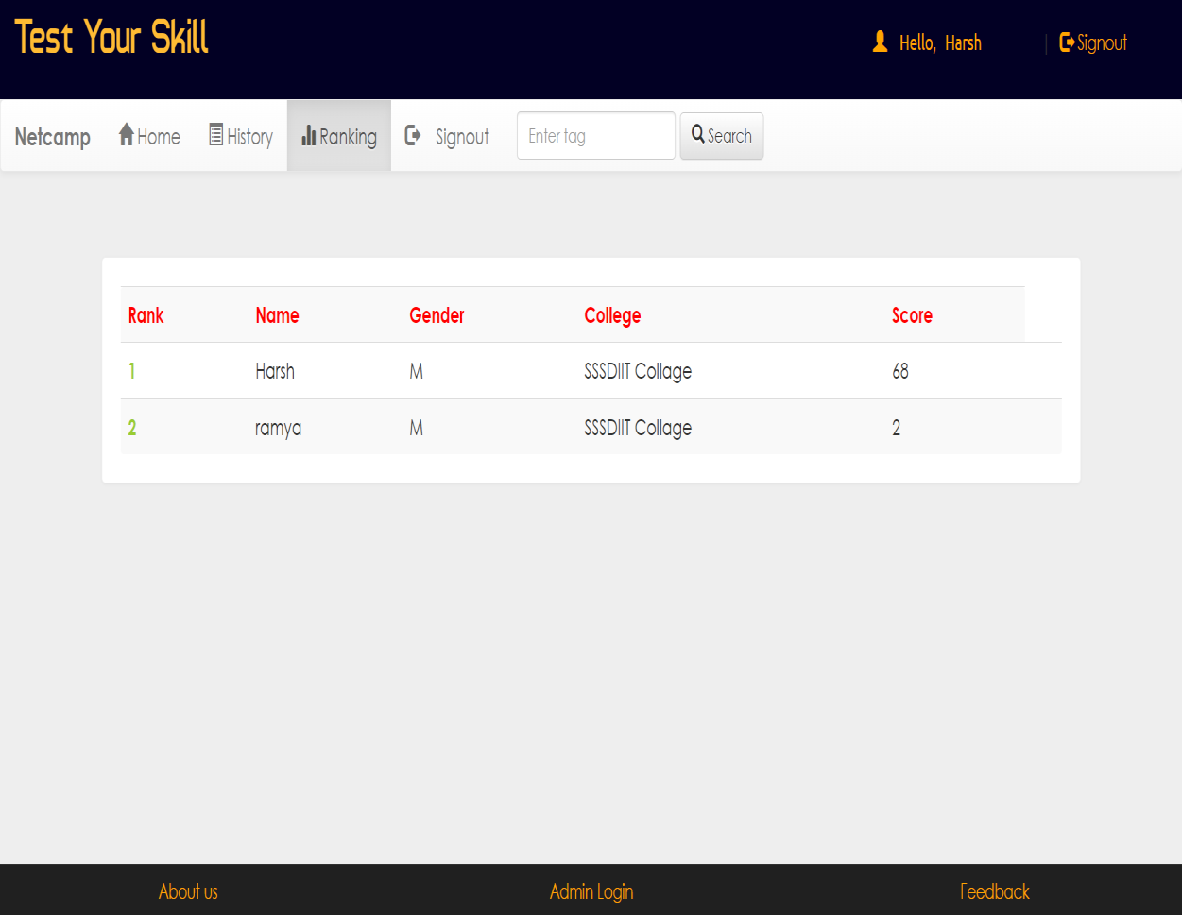

if (@$_GET['q'] == 3)

{

$q12 = mysqli_query($con, "SELECT * FROM user WHERE email='$e' ") or die('Error231');

while ($row = mysqli_fetch_array($q12))

{

$name = $row['name'];

$gender = $row['gender'];

$college = $row['college'];

}

}

## Admin Side :

1. 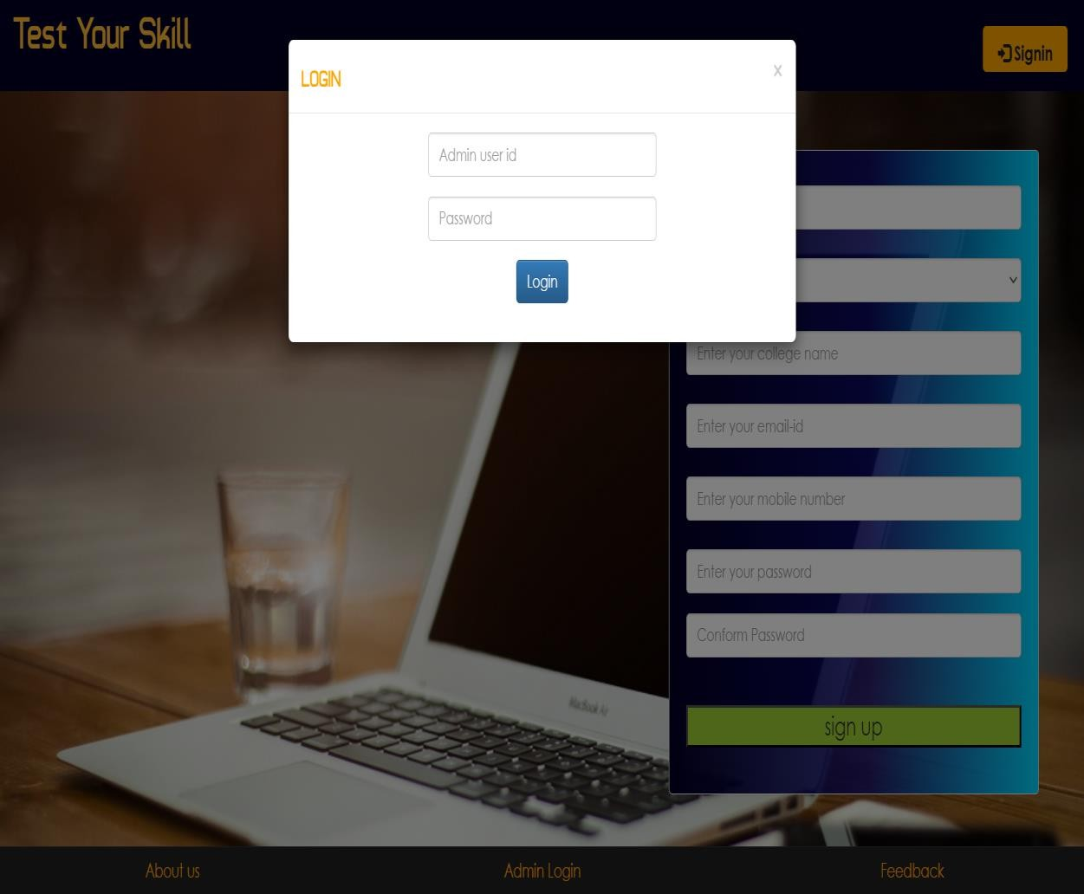**Index.php(Login)**

<-- Login -->

$result = mysqli_query($con,"SELECT email FROM admin WHERE email = '$email' and password = '$password'") or die('Error');

$count=mysqli_num_rows($result); if($count==1)

{

session_start(); if(isset($_SESSION['email']))

{

session_unset();

}

$_SESSION["email"] = $email; header("location:dash.php?q=0");

}

else header("location:$ref?w=Warning : Access denied");

## dash.php?q=0

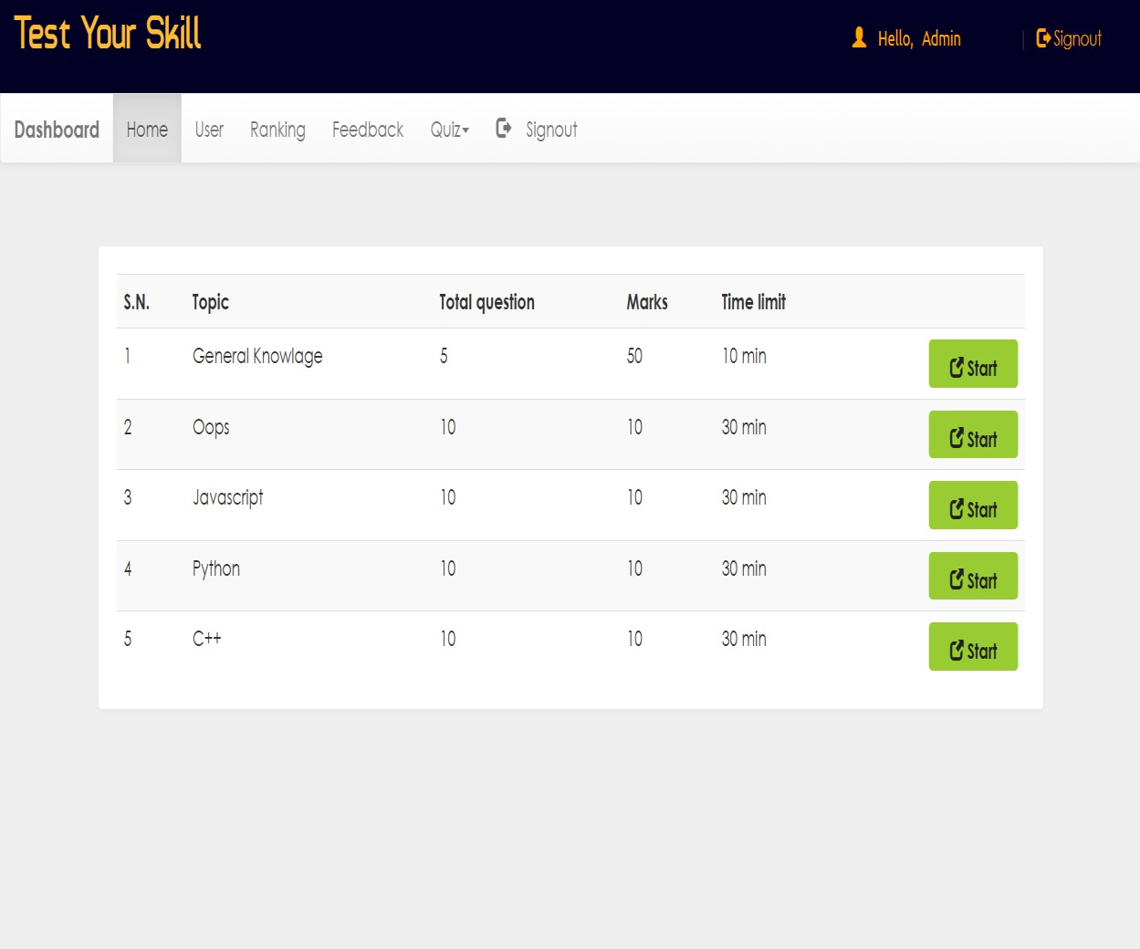

1. **dash.php?q=1**

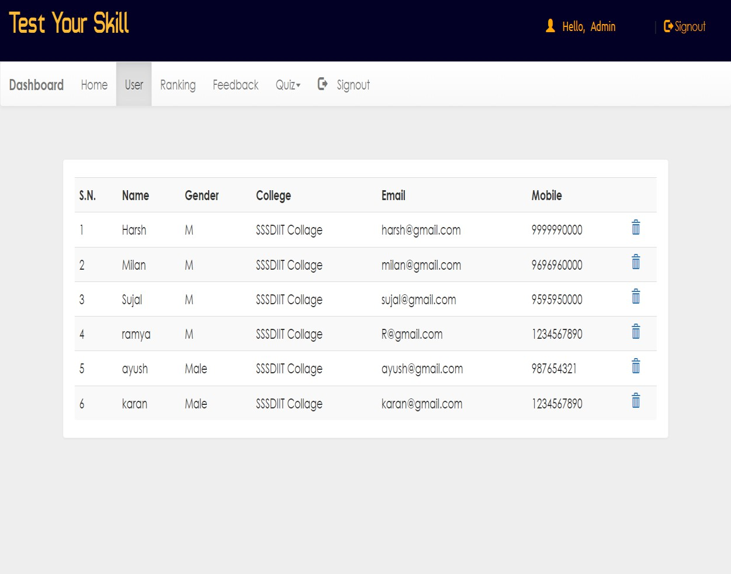

<-- DELETE -->

if (isset($_SESSION['key']))

{

if (@$_GET['demail'] && $_SESSION['key'] == 'harsh')

{

$demail = @$_GET['demail'];

$r1 = mysqli_query($con, "DELETE FROM rank WHERE email='$demail' ") or die('Error');

$r2 = mysqli_query($con, "DELETE FROM history WHERE email='$demail' ") or die('Error');

$result = mysqli_query($con, "DELETE FROM user WHERE email='$demail' ") or die('Error');

header("location:dash.php?q=1");

}

}

## dash.php?q=2

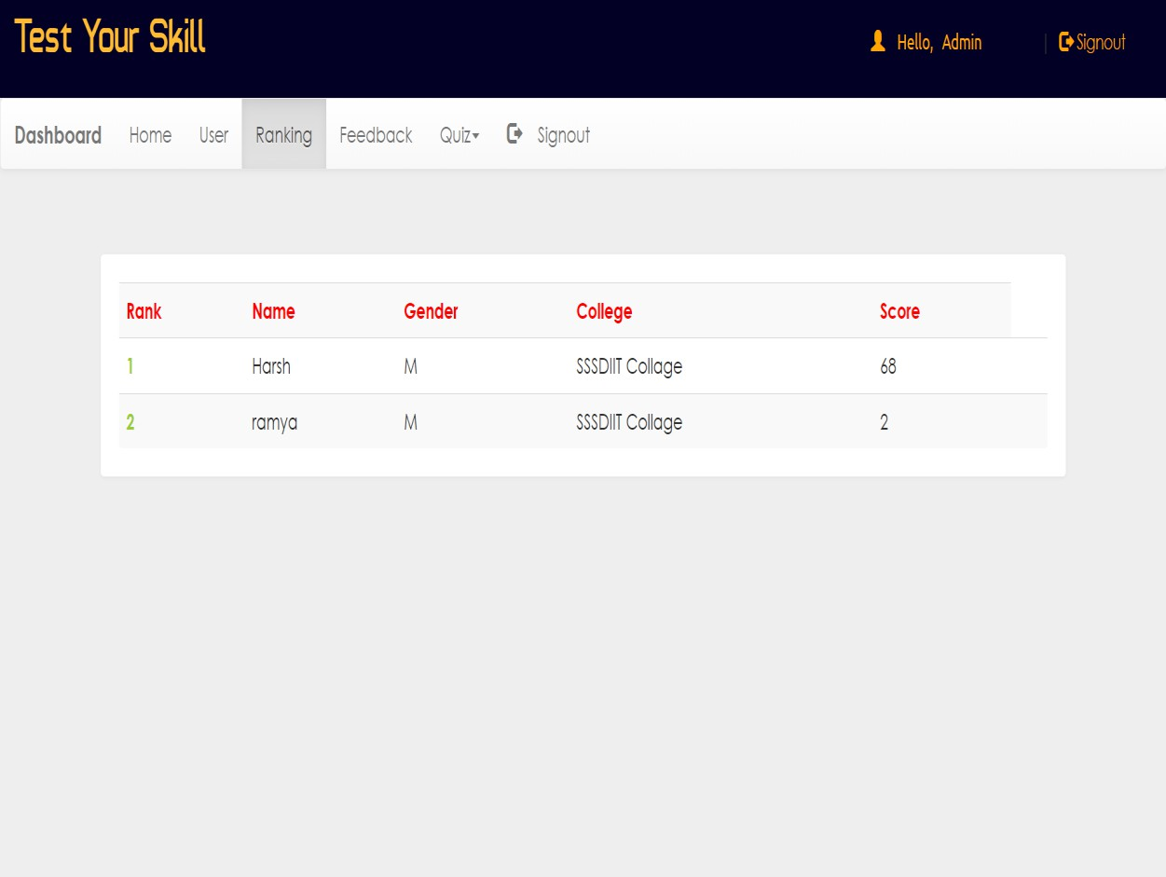

1. **dash.php?q=3**

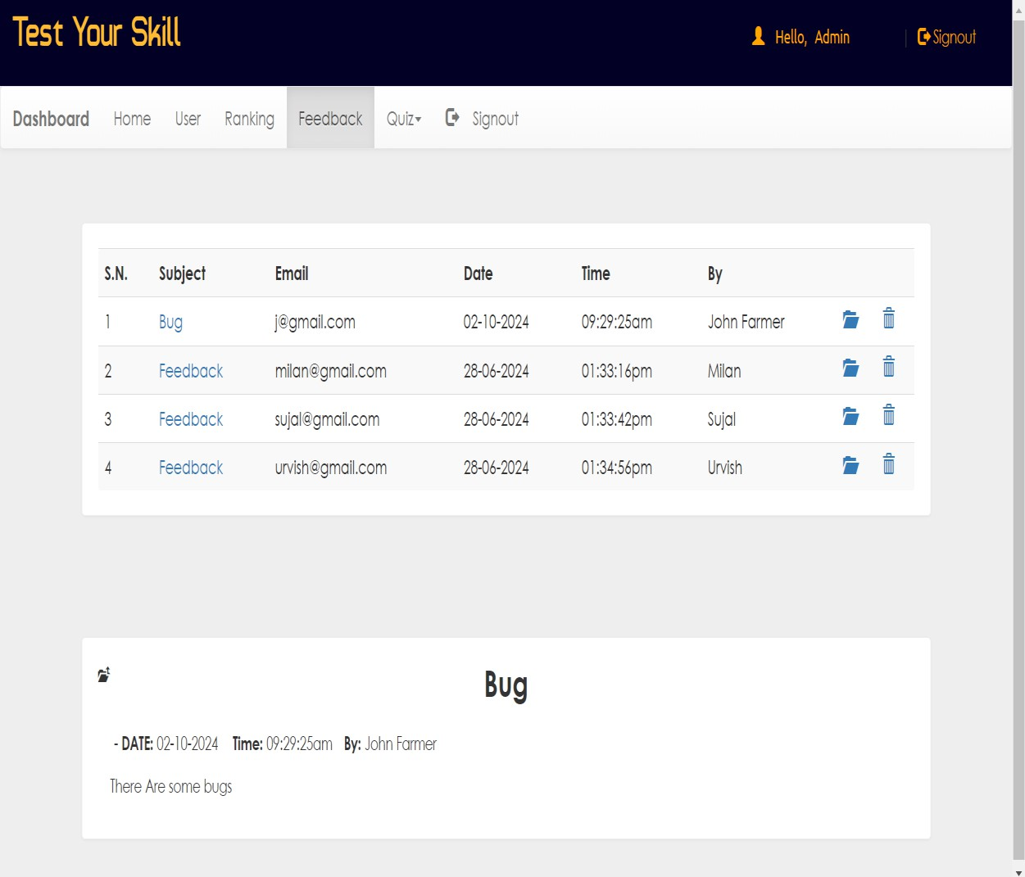

<?php if (@$_GET['q'] == 3)

{

$result = mysqli_query($con, "SELECT * FROM `feedback` ORDER BY

`feedback`.`date` DESC") or die('Error');

}

<-- DELETE -->

if (isset($_SESSION['key']))

{

if (@$_GET['fdid'] && $_SESSION['key'] == 'harsh')

{

$id = @$_GET['fdid'];

$result = mysqli_query($con, "DELETE FROM feedback WHERE id='$id' "); header("location:dash.php?q=3");

}

}

## dash.php?q=4

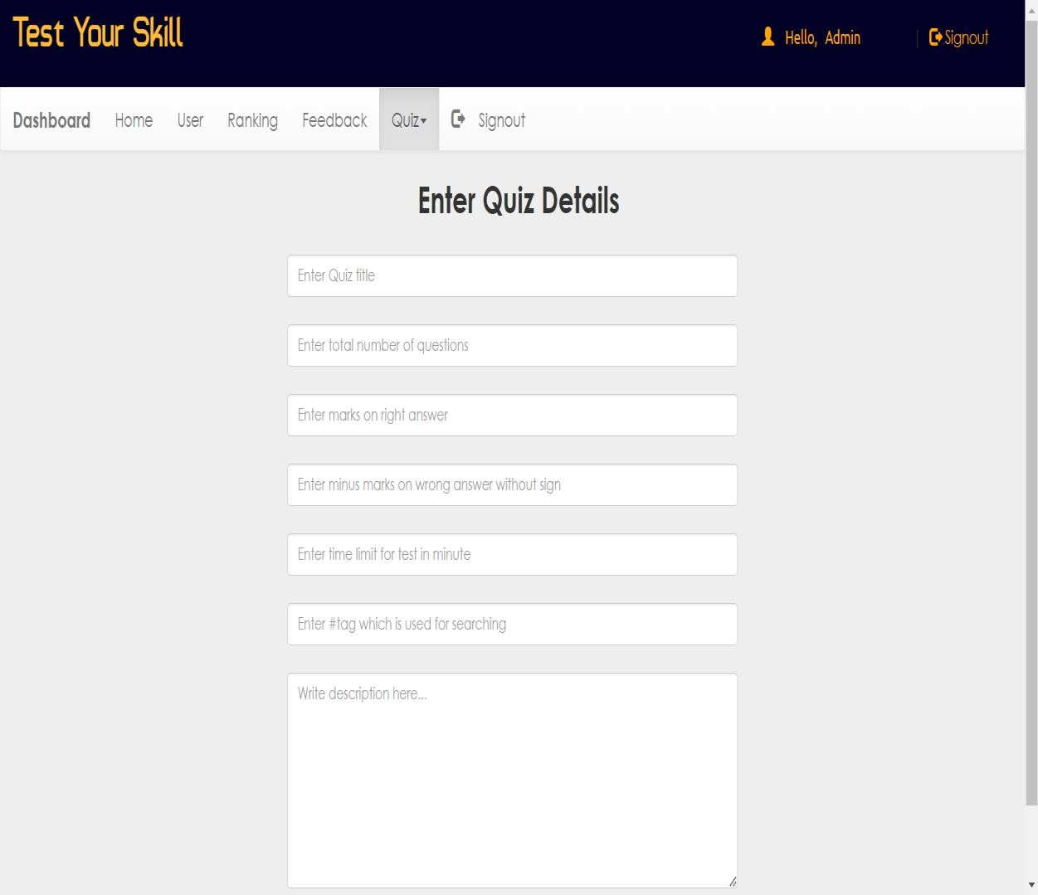

if (@$_GET['q'] == 4 && (@$_GET['step']) == 2)

{

for ($i = 1; $i <= @$_GET['n']; $i++)

{

<-- Design -->

}

}

## dash.php?q=5

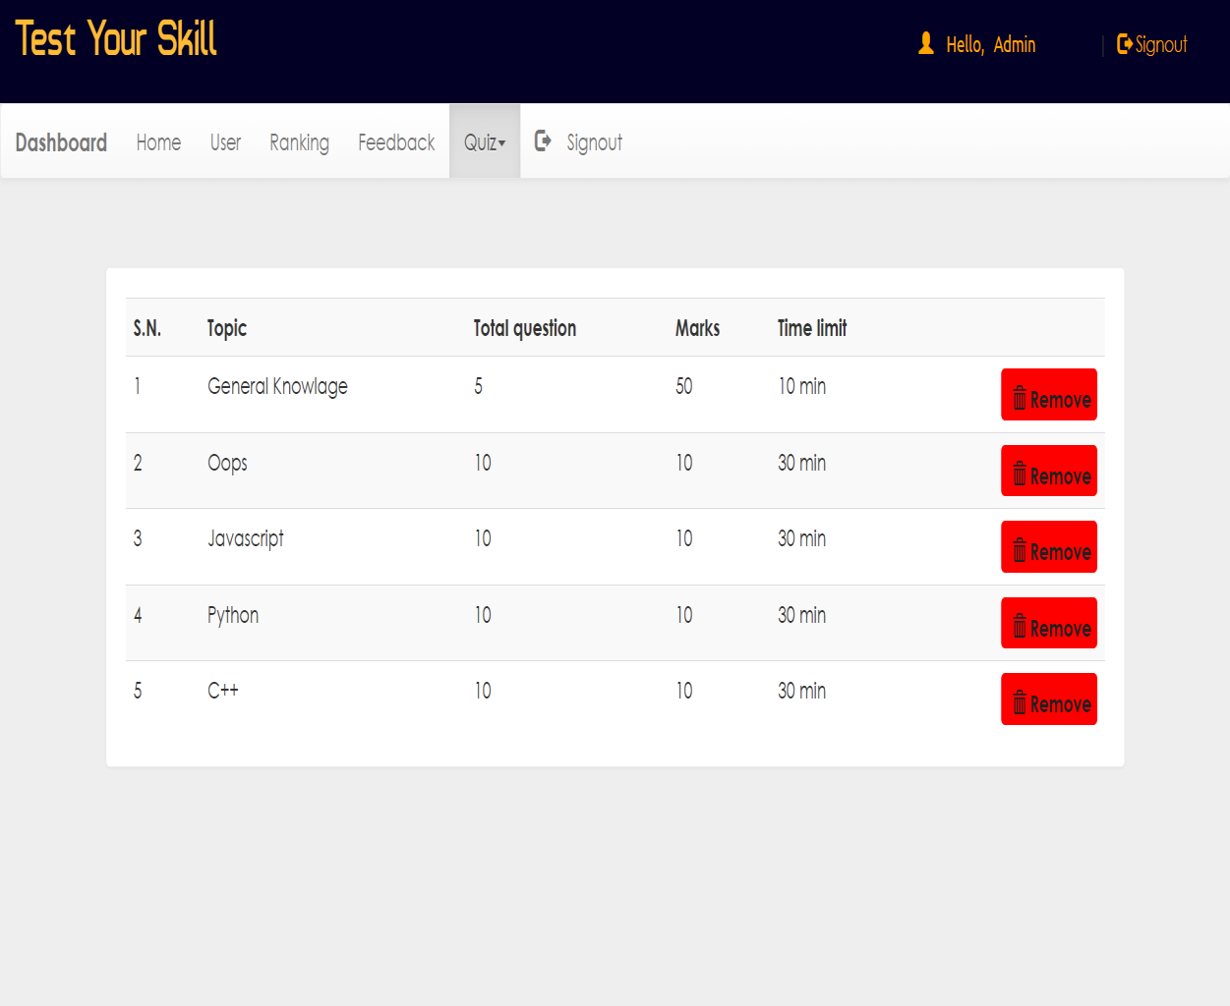

<?php if (@$_GET['q'] == 5)

{

$result = mysqli_query($con, "SELECT * FROM quiz ORDER BY date DESC") or die('Error');

}

<-- DELETE -->

$result = mysqli_query($con, "SELECT * FROM questions WHERE eid='$eid' "); while ($row = mysqli_fetch_array($result))

{

$qid = $row['qid'];

$r1 = mysqli_query($con, "DELETE FROM options WHERE qid='$qid'");

$r2 = mysqli_query($con, "DELETE FROM answer WHERE qid='$qid' ")

}

$r3 = mysqli_query($con, "DELETE FROM questions WHERE eid='$eid' ");

$r4 = mysqli_query($con, "DELETE FROM quiz WHERE eid='$eid' ");

$r4 = mysqli_query($con, "DELETE FROM history WHERE eid='$eid' "); header("location:dash.php?q=5");

1. **feedback.php**

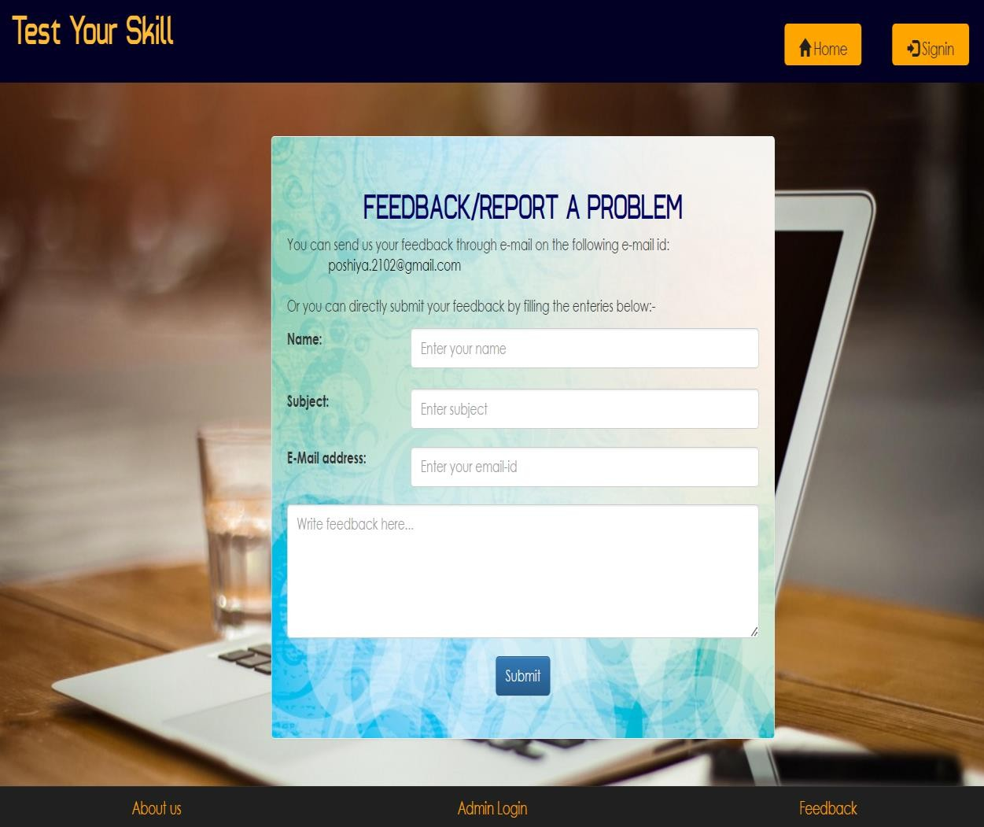

# SPECIAL UTILITIES

### Timer for Examination

* + The system includes a countdown timer for each exam, ensuring that students complete the test within a fixed time frame. Once the timer expires, the exam is automatically submitted.

### Instant Result Generation

* + After the exam submission, results are calculated and displayed instantly for objective-type questions like MCQs and True/False. The system also provides detailed feedback for incorrect answers, if enabled.

### Secure Login System

* + A secure login system ensures that only authenticated users can access the platform, with different levels of access rights for students, examiners, and administrators.

### Feedback System

* + After the completion of the exam, students can provide feedback on the exam process, the quality of questions, and the overall experience, which helps in improving the examination system.

# TESTING

Testing is a process of executing a program with the indent of finding an error. Testing is a crucial element of software quality assurance and presents ultimate review of specification, design and coding.

System Testing is an important phase. Testing represents an interesting anomaly for the software. Thus a series of testing are performed for the proposed system before the system is ready for user acceptance testing.

A good test case is one that has a high probability of finding an as undiscovered error. A successful test is one that uncovers an as undiscovered error.

#### Testing Objectives:

1. Testing is a process of executing a program with the intent of finding an error
2. A good test case is one that has a probability of finding an as yet undiscovered error
3. A successful test is one that uncovers an undiscovered error

#### Testing Principles

1. All tests should be traceable to end user requirements
2. Tests should be planned long before testing begins
3. Testing should begin on a small scale and progress towards testing in large 4.Exhaustive testing is not possible

5.To be most effective testing should be conducted by a independent third party

The primary objective for test case design is to derive a set of tests that has the highest livelihood for uncovering defects in software. To accomplish this objective two different categories of test case design techniques are used. They are

White box testing. Black box testing.

**White-box testing:**

White box testing focus on the program control structure. Test cases are derived to ensure that all statements in the program have been executed at least once during testing and that all logical conditions have been executed.

**Block-box testing:**

Black box testing is designed to validate functional requirements without regard to the internal workings of a program. Black box testing mainly focuses on the information domain of the software, deriving test cases by partitioning input and output in a manner that provides through test coverage. Incorrect and missing functions, interface errors, errors in data structures, error in functional logic are the errors falling in this category.

#### Testing strategies:

A strategy for software testing must accommodate low-level tests that are necessary to verify that all small source code segment has been correctly implemented as well as high-level tests that validate major system functions against customer requirements.

#### Testing fundamentals:

Testing is a process of executing program with the intent of finding error. A good test case is one that has high probability of finding an undiscovered error. If testing is conducted successfully it uncovers the errors in the software. Testing cannot show the absence of defects, it can only show that software defects present.

#### Testing Information flow:

Information flow for testing flows the pattern. Two class of input provided to test the process. The software configuration includes a software requirements specification, a design specification and source code.

Test configuration includes test plan and test cases and test tools. Tests are conducted and all the results are evaluated. That is test results are compared with expected results. When erroneous data are uncovered, an error is implied and debugging commences.

#### Unit testing:

Unit testing is essential for the verification of the code produced during the coding phase and hence the goal is to test the internal logic of the modules. Using the detailed design description as a guide, important paths are tested to uncover errors with in the boundary of the modules. These tests were carried out during the programming stage itself. All units of ViennaSQL were successfully tested.

#### Integration testing :

Integration testing focuses on unit tested modules and build the program structure that is dictated by the design phase.

System testing:

System testing tests the integration of each module in the system. It also tests to find discrepancies between the system and it’s original objective, current specification and system documentation. The primary concern is the compatibility of individual modules. Entire system is working properly or not will be tested here, and specified path ODBC connection will correct or not, and giving output or not are tested here these verifications and validations are done by giving input values to the system and by comparing with expected output. Top-down testing implementing here.

#### Acceptance Testing:

This testing is done to verify the readiness of the system for the implementation. Acceptance testing begins when the system is complete. Its purpose is to provide the end user with the confidence that the system is ready for use. It involves planning and execution of functional tests, performance tests and stress tests in order to demonstrate that the implemented system satisfies its requirements.

#### Tools to special importance during acceptance testing include:

**Test coverage Analyzer** – records the control paths followed for each test case.

**Timing Analyzer** – also called a profiler, reports the time spent in various regions of the code are areas to concentrate on to improve system performance.

**Coding standards** – static analyzers and standard checkers are used to inspect code for deviations from standards and guidelines.

#### Test Cases:

Test cases are derived to ensure that all statements in the program have been executed at least once during testing and that all logical conditions have been executed.

Using White-Box testing methods, the software engineer can drive test cases that

* Guarantee that logical decisions on their true and false sides.
* Exercise all logical decisions on their true and false sides.
* Execute all loops at their boundaries and with in their operational bounds.
* Exercise internal data structure to assure their validity.

The test case specification for system testing has to be submitted for review before system testing commences.

# IMPLEMENTATION

This application avoids the manual work and the problems concern with it. It is an easy way to obtain the information regarding the different scheduled examinations information that are Currently issued.

Well I and my team members have worked hard in order to present an improved website better than the existing one’s regarding the information about the various activities. Still ,we found out that the project can be done in a better way. Primarily, when we request information about a particular schedules it just shows the exam date and platform. So, after getting the information we can get access to the online exam.

The enhancement that we can add the searching option. We can directly search to the particular student details from this site.

The implementation is processed from review and reports from developer cover the following areas:

* Good working conditions.
* Useful for gathering information.
* Update website easily.
* Attractive layouts.
* Working for as per requirements.

# BIBLIOGRAPHY

The following books were referred during the analysis and execution phase of the project

### Books Referred:

* + BEGINNING PHP 5 ---DAVE MERCER
  + PHP AND MYSQL WEB DEVELOPMENT --- LUKEWELLING,LAURA
  + PHP IN A NUTSHELL --- PAUL HUDSON

### Internship Experience :

**Sparks To Ideas. *PHP Development Internship* (1st may – 31st may 2024-Ahemedabad)**

* During this internship, I gained hands-on experience in developing web applications using PHP. I worked on backend functionalities, including database integration with MySQL, form handling, and session management. This internship was crucial in enhancing my understanding of real-world PHP development, and the skills acquired were applied directly to the development of the Online Examination System project.